**Introduction:**

Government Survey - Dengue Malaria

Vector-borne diseases (VBDs) are a menace for developing countries due to the explosive number of cases reported annually. Outbreaks of VBDs such as dengue and malaria can overwhelm health systems in resource-poor countries. Dengue fever is the most common human arboviral infection globally, transmitted by Aedes aegypti and Aedes albopictus mosquitoes. It is responsible for more illnesses and deaths than any other arboviral disease. The frequency of outbreaks in India has risen with time. Just like dengue, India is plagued with another VBD, Malaria. Southeast Asia is severely affected by malaria, and India contributes 77% of the disease burden in this area.

In the absence of readily available vaccines, environmental management strategies and preventive personnel measures can effectively reduce the burden of these diseases. Hence, to achieve the best results in vector control, it is imperative to have active community participation through improved knowledge and health-promoting practices. As with many community health problems, the population’s knowledge, attitude, and methods play a significant role in implementing control measures for VBDs.

Hence, our team of 10 people undertook the task of spreading awareness in the rural areas about such harmful diseases and briefing them regarding preventive measures during the monsoon.

Survey for the Overall Development of the Village :

Symbiosis International University has adopted several villages in and around Sus village. Mulkhed is a similar village adopted by SCOPE (NGO of the Symbiosis International University). The town consists of approximately 500 people. This survey was led by the students of Third Year EnTC, who went to the village to collect data about various aspects on various topics related to the well-being of the village people.

**Team Members :**

1. Dhruv Dolas (20070123015)

2. Yash Khairnar (20070123023)

3. Rugwesh Kolekar (20070123024)

4. Avinash Shukla (20070123056)

5. Om Kamble (20070123066)

6. Anoushka Pandit (20070123068)

7. Arohi Rathod (20070123072)

8. Aaliya Shaikh (20070123084)

9.Tarush Pandey (20070123088)

10. Parth Nikam (20070123120)

**Literature Review :**

This Service-Learning activity was divided into three parts-

1) Awareness survey to educate people about Dengue and Malaria.

2) Developmental survey to inspect the economic and social conditions in Mulkhed village.

3) Analysing the data acquired in the above surveys.

In the first part of this activity, we were sent in several groups to Mulkhed village to spread awareness about Dengue and Malaria. We went from house to house, inquiring people about their recent health concerns to see if any of those matched with the symptoms of the diseases. We also inspected their surroundings to ensure water wasn’t accumulating to provide breeding grounds for mosquitoes and put medicine in such open water accumulation.

The second part was the developmental survey. The current study focuses on the Mulkhed block falling under the Pune district. The study villages are located at the base of Sahyadri hills, 20 km west of Pune. Mulkhed is adjoining the Mulshi block with patches of dense tribal populations. The place is known for its forest and dams. Crops like Bajara and Rice and vegetables like Tomato, Potato and Onion are grown in areas receiving irrigation facilities.

Here, most of the cultivation happens during the monsoon (June to September). Therefore, rainfall plays an essential role in the life and livelihood of the villagers.

We went to the same village again with a questionnaire. This helped us understand the socioeconomic conditions of the people.

This helped us understand their lifestyle better, and the accumulated data will help understand their needs concerning employment and educational opportunities.

The final part of the activity was data analysis. The data was collected and sorted according to our needs. Various graphs showing literacy distribution, employment distribution etc. have been made to get a better understanding of the living situation of the people of Mulkhed Village.

**Work Done and Method used:**

Government Survey (Dengue-Malaria)

● We Visited Mulkhed Village near Pune

● Data was collected with a pretested self-administered questionnaire. The questionnaire covered the following areas: sociodemographic characteristics (sex, age, marital status, education, and number of members in household), knowledge, personal experience, and practices regarding VBDs.

● Asked them a few questions to check whether they had any symptoms of the listed Diseases and recommended a few to visit a doctor

● After collecting the pretest questionnaire, the participants attended a workshop on prevention and control of VBDs

● Used Medicinal Solution provided by ASHA Worker to eradicate the larvae present in the various sources of stagnant water explored by the team

● We Advised them to Close all the open water Drums and Tanks and also briefed them regarding prevention of Water Contamination

**Survey for Overall development of the Village :**

In this month, the students went to Mulkhed to conduct a survey about various topics which affect the day-to-day living of the people. We tried to cover the following topics while asking questions to the people.

Rough details given by the people:

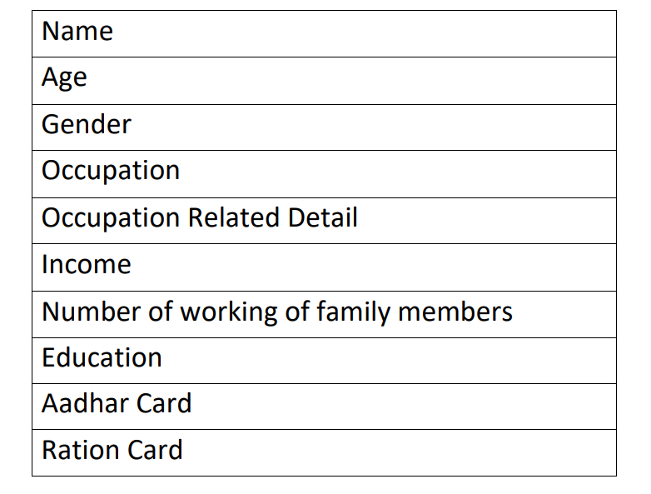

Details such as name, age and gender were the basic introductory questions asked by the group. Followed by the occupation that the family is involved into. It was observed that most of the families were into farming profession. Questioning about the income can be a bit uncomfortable for the villagers to talk about therefore, we made an effort to make them comfortable first and then ask the questions. We analysed the income based on the monthly salary they receive. For example, data was taken on the basis of monthly income being less than 22K or more than 22K. It was observed that most of them had a salary less than 22K. Further we asked about the number of working persons in the family, their education background. It is extremely important to have an aadhar card and ration card. Therefore we took details based on their aadhar and ration card, whether or not they own it.

Apart from this we also rated the houses on the basis of the sanitation and hygiene. Moreover, apart from the questionnaire, we asked the villagers if they are facing any other issues: Their response:

1) 50% of the people said that the village needs a small clinic with health facilities nearby because it is not feasible for them to travel long distances when any family member is sick in search of the hospitals.

2) They requested us if we could give some kind of employment opportunity to the members of the family who have no income so that they could manage their expenses and family.

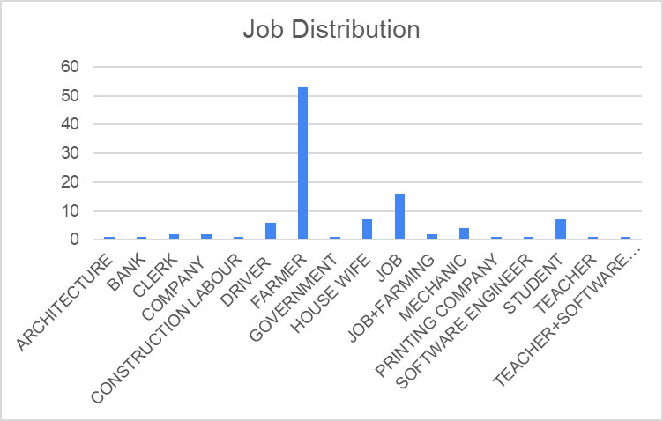

1. Domains in which the villagers work

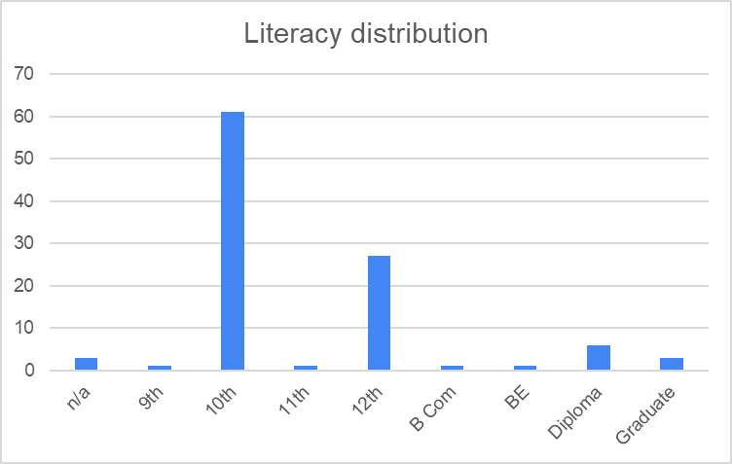

1. Literacy of the members of the family

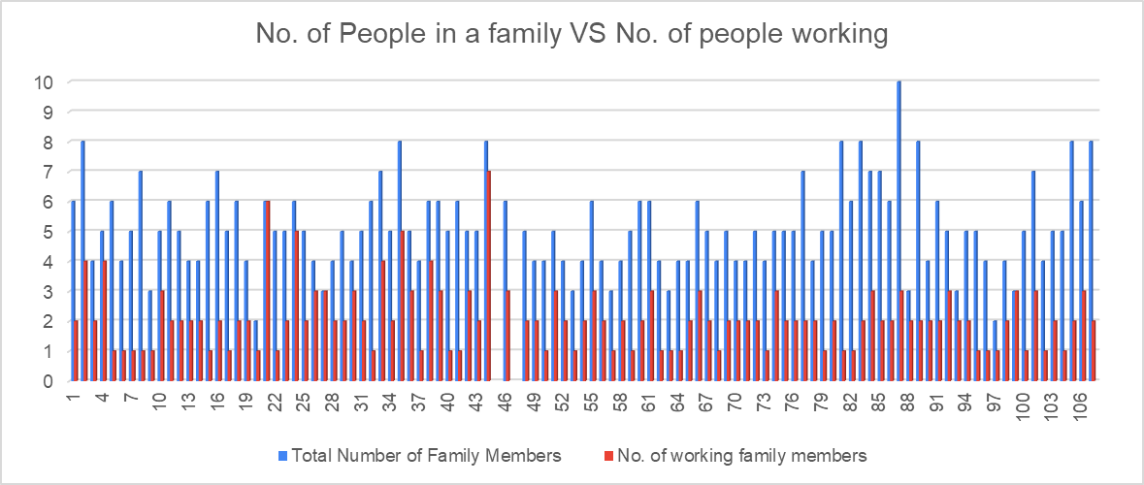

(c) Number of working members in a family

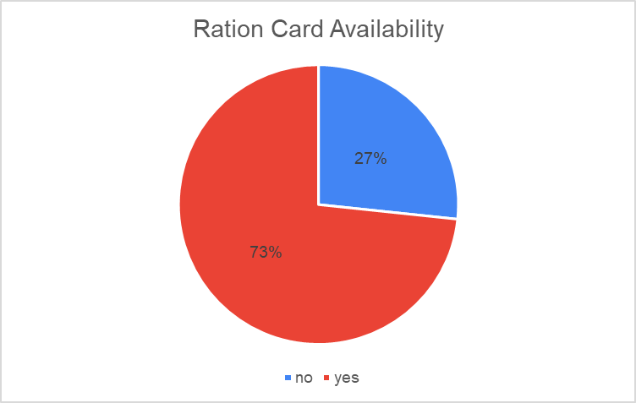

(d) Availability of Ration Card in the village

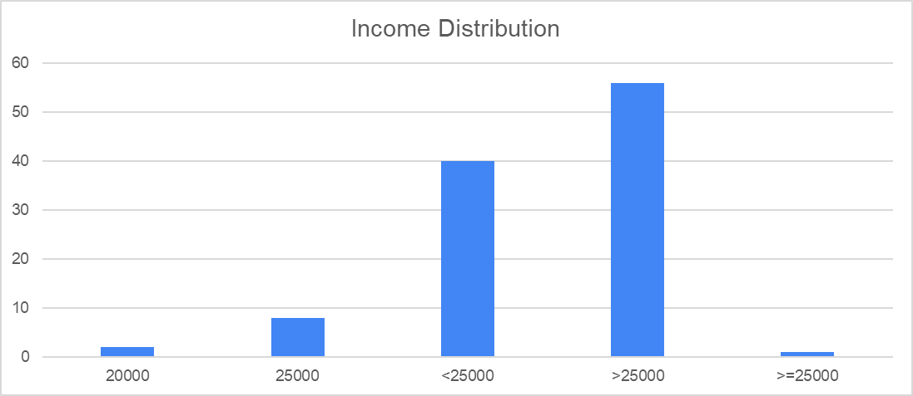

(e) Income of the villagers

Photos :

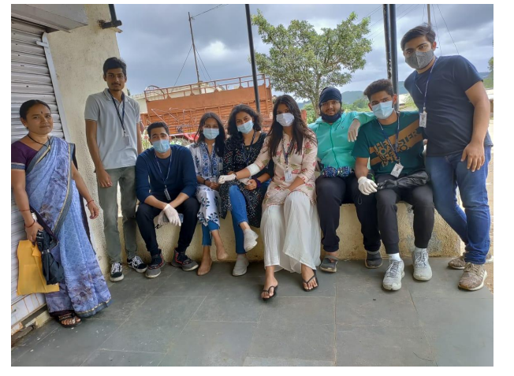

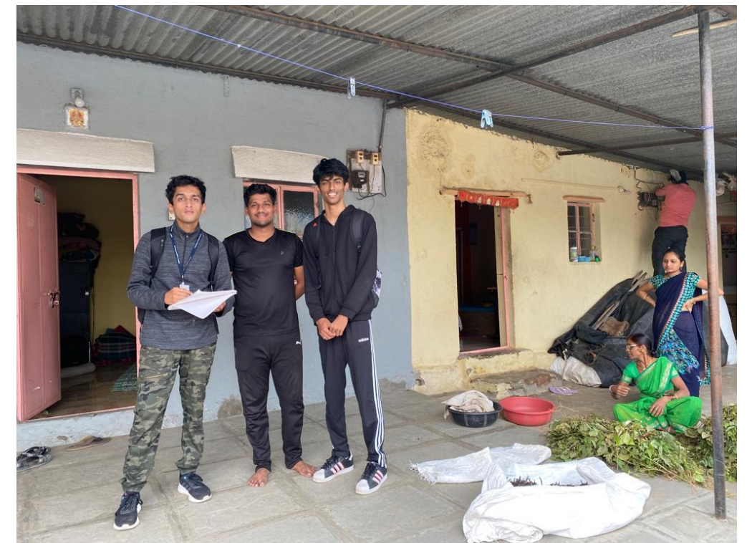

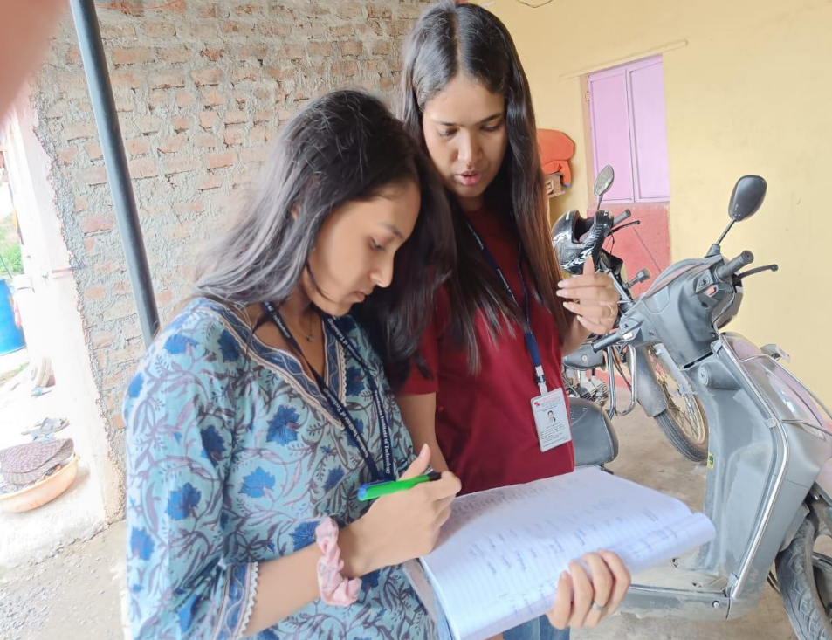

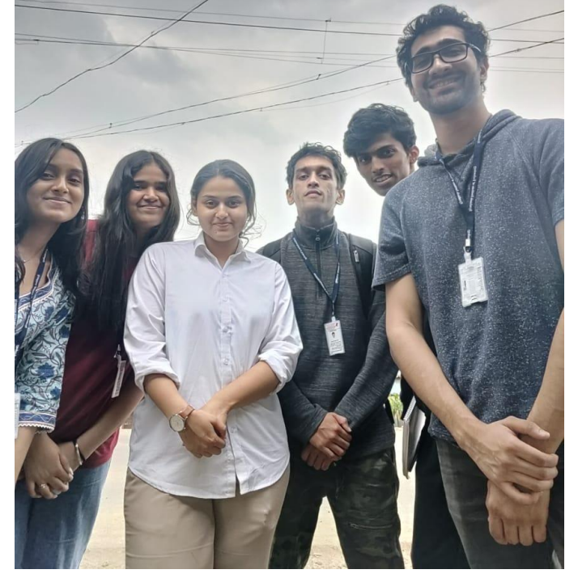

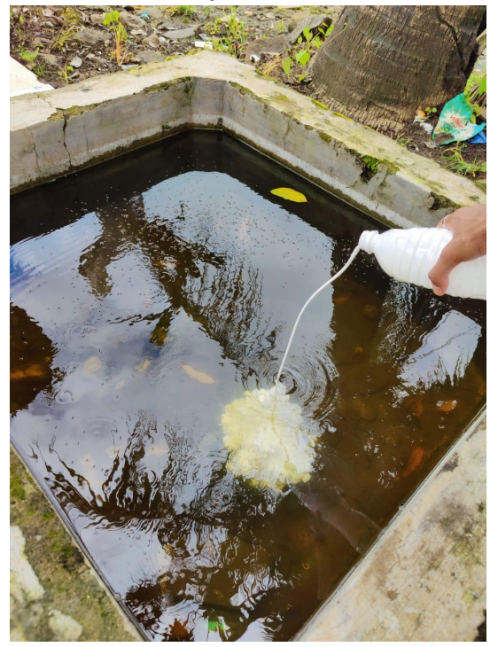

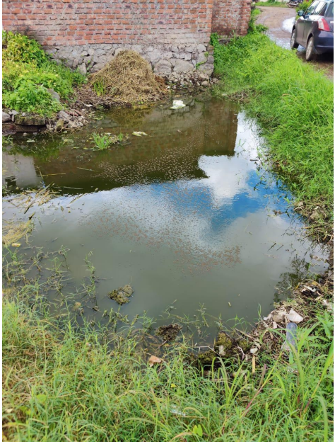

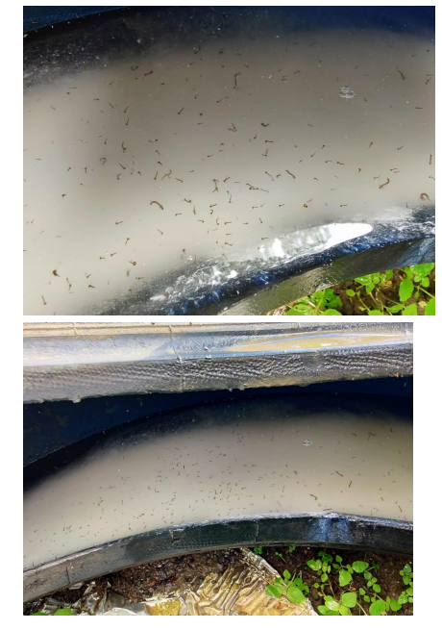

**Conclusion :**

A proper survey was conducted. It was made sure that the villagers felt comfortable while interacting with us. We asked questions based on their family, family occupation, income, aadhar card, ration card. We also rated the hygiene and sanitation of the houses to have a better judgement of the situation at hand. Further, we have analyzed the data that we gathered throughout our visits and have drawn some meaningful insights which will contribute in the development of this particular village.